Project Proposal

Problem Statement

Background and Context of the Problem
Brain tumours are one of the most serious conditions in the field of neurology as it is highly morbid and fatal, especially in case of late or wrong diagnosis. Magnetic Resonance Imaging (MRI) is the leading form of imaging of the brain tumour due to its high levels of spatial resolution and high-quality soft-tissue contrast (Pereira et al., 2020). Nevertheless, the interpretation of MRI scans is a time-consuming, expertise-dependent and complex procedure, which may necessitate the use of experienced radiologists in order to analyse large amount of images under high pressure of clinical work (Tandel et al., 2021). With the continued growth in the number of patients via the healthcare systems, the demand to have intelligent systems that can assist clinicians in the system by analysing images rapidly and reliably is on the increase.

Limitations of Traditional and Existing Approaches
Traditionally, computer-aided diagnosis models have used extensive handcrafted feature selection and standard machine learning classifiers that are incapable of receiving complex and high-level features such as those found in medical images (Sultana et al., 2020). Although the deep learning models, especially the Convolutional Neural Networks (CNNs), have shown to have better results in the brain tumour classification tasks, their application in actual clinical settings has not been widely adopted because of their black-box characteristics (Samek et al., 2021). The absence of transparency in decision-making provokes the issues of trust, accountability, and ethical responsibility, particularly in high-risk medical applications (Holzinger et al., 2020).

Importance of Explainability in Medical AI Systems
Explainable Artificial Intelligence (XAI) has become an important direction of research to solve the interpretability gap of deep learning models. Visualisation Techniques Visual explanations can be done by using methods like Gradient-weighted Class Activation Mapping (Grad-CAM), which highlights the areas of an input image that the model relies on the most to make its prediction (Selvaraju et al., 2020). These visual explanations are also critical in the medical field because model decisions should be made according to clinically relevant features and not according to artefacts or noise (Arun et al., 2021). Explainability enhances clinician trust, but it can also sustain ethical and responsible use of AI because it enables critical assessment of the behaviour of models and possible bias (Ghassemi et al., 2021).

Target Beneficiaries and Project Selling Point
The main stakeholders of this project are the radiologists, medical researchers and healthcare institutions that are interested in decision support tools used to aid in the interpretation of MRI images. Patients are secondary beneficiaries as they may have a positive impact on the results of more timely and regular primary examinations (Tjoa and Guan, 2020). The main selling point of the project is that it combines high-performance deep learning classification and Grad-CAM-based explainability, which allows making correct predictions as well as clearly visual explainability. The given approach focuses on interpretability, ethicality, and trust, unlike pure accuracy-driven systems, which makes it a supportive tool and not a substitute of medical professionals (Topol, 2019).

Technical Approach

Proposed AI and Data Science Techniques
This project embraces sophisticated computer vision methods of deep learning to deal with the issue of brain tumour classification using MRI images. Convolutional Neural Networks (CNNs) serve as the (Samek et al., 2021) fundamental modelling tool because it has been shown to learn hierarchical spatial features of medical imaging data (Tandel et al., 2021).
Figure 2 : Horizontal workflow of the proposed explainable deep learning system, showing MRI preprocessing, CNN-based classification with transfer learning, performance evaluation, and Grad-CAM visual interpretation.
Transfer learning is applied to improve the model performance and convergence rates by using pre-trained CNN architectures that have been fine-tuned using the target MRI data (Sharma et al., 2020). Moreover, visual explanations of the prediction of the model in the form of Explainable Artificial Intelligence (XAI) methods, namely Gradient-weighted Class Activation Mapping (Grad-CAM), are also included to enhance the transparency and trust of high-risk models in the medical setting (Selvaraju et al., 2020).

Data Pipeline and Pre-processing Strategy
The pipeline starts with the intake of the MRI images of a publicly accessible, labelled dataset of brain tumours. Image resizing, intensity normalisation, and scaling of the pixel values are part of the pre-processing that is done to bring uniformity to the sample as well as to enhance stability of the models used in training (Sultana et al., 2020). The data augmentation methodology, including rotation, flipping, and zooming, is used to avoid overfitting and enhance the performance of generalisation, especially in small size medical imaging datasets (Shorten and Khoshgoftaar, 2019).
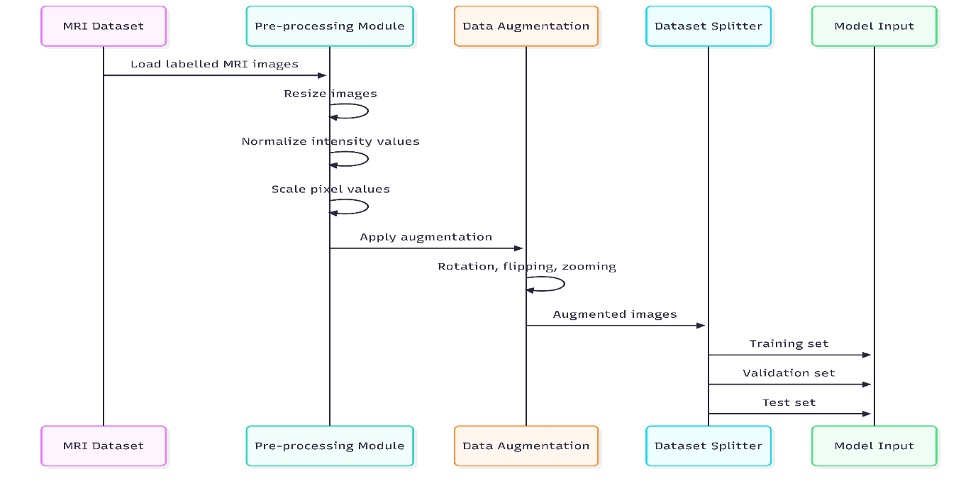
Figure 3: Sequence diagram illustrating the MRI data pipeline, including preprocessing, augmentation, and dataset splitting for model training and evaluation.
Thereafter, the processed images are divided into training, validation and testing groups to facilitate a sound performance estimation and objective evaluation.

System Architecture and Model Design
The proposed system architecture will include a CNN-based classification network that is then completed by a SoftMax output layer to classify the tumour types. The architecture has been created to strike a balance between complexity of models and computational efficiency such that it is suitable to be used in both experimentation and live demonstration. Grad-CAM is also used as a post-hoc interpretability method and produces heatmap images showing the most salient regions of the image to a single prediction (Arun et al., 2021). This modular design enables the evaluation of predictive performance and explainability independently, which facilitates the system design with a structure and extensible system design which conforms to the principles of responsible AI (Holzinger et al., 2020).
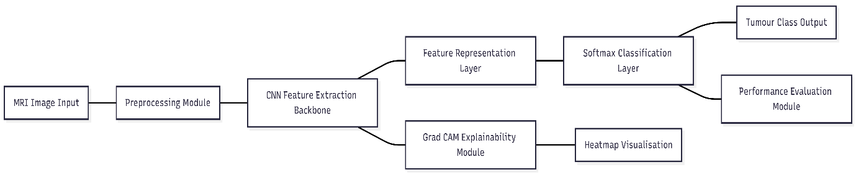
Figure 4 : Block architecture of the proposed explainable CNN-based brain tumour classification system with integrated Grad-CAM and performance evaluation modules.

Learning Outcomes and Alignment with Intelligent Systems
The given project provides the opportunity to explore the modern intelligent systems through the combination of the data-driven deep learning models and the mechanisms of explainability. The project, in particular, provides a direct solution to the creation of practical and ethical AI solutions by designing and implementing a full AI pipeline, including data acquisition, inference and interpretation stages (Tjoa and Guan, 2020). It shows the use of highly-developed computer vision methods and it promotes thinking critically on the behaviour of these models, their constraints and the effects on the society. Consequently, the project assists in the transferability of skills in the design of AI systems, their assessment, and responsible use, in line with postgraduate learning outcomes related to advanced artificial intelligence and data science (Ghassemi et al., 2021).

